**Microsoft Excel: Financial Tools**

### **Microsoft Excel**

* Go to the Course Website
* Download and print “Business Analytics – Week 2 Instructions.doc”
* Download “Business Analytics – Week 2 Excel 2013”

**Session 2.3: Net present value**

Net present value is used in finance to determine a value of a future stream of money in today’s dollars. Net present value determines what a revenue stream would be worth in today’s dollars. There are two NPV functions: NPV calculates the net present value of a stream of money at regular intervals; XNPV calculates the NPV of a stream of money at irregular intervals.

NPV(rate, range of cells)

XNPV(rate, values, dates)

The NPV calculation assumes that all cash flow is at the end of the period.

In the example below (NPV spreadsheet), investments are entered as negative numbers, returns as positive. Calculate the NPV for Options 1, 2 and 3 and enter the formulas in cells C3, D3, E3.

1. To calculate the NPV of Option 1, in cell C3, enter the formula for NPV.
2. For rate, refer to cell G4
3. For range of cells, highlight the investment and returns (cells C4:C20)
4. Similarly, calculate the NPV for Options 2 and 3

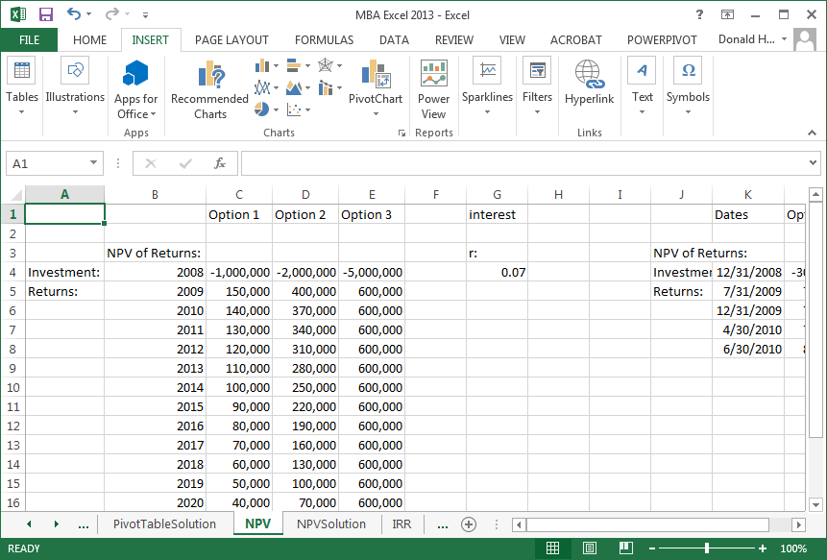

Now calculate the NPV of Option 4 using the XNPV formula and enter it in cell L3.

**Session 2.4: Internal rate of return**

The internal rate of return (IRR) calculates what the interest rate would have to be so that the NPV is zero. In some situations, there is no IRR. The spreadsheet is set up similar to the NPV problem, but investments are listed as negative returns. The function for IRR is:

IRR(data range)

The IRR spreadsheet gives an example of three investment options, revenue streams, and the calculated IRR. A corporation would compare the IRR to the possible returns available elsewhere to determine if a project was worthwhile.

In cell B2, enter the formula for IRR of Option 1. Similarly, calculate the IRR for Options 2 and 3 in cells C2 and D2.

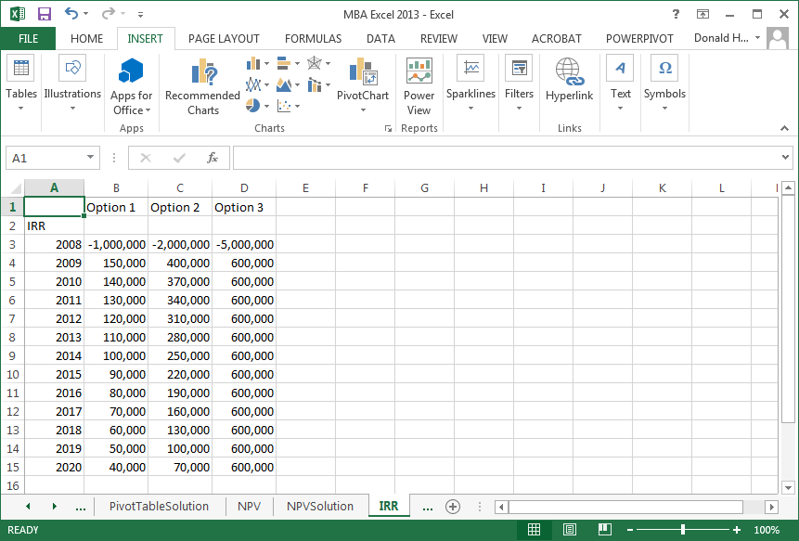

**Microsoft Excel: Statistics**

**Session 2.5: Data Analysis Add-in**

The statistics options are available as an add-in to Excel. The steps to add it are:

1. In Excel, click on the File tab, then Options
2. Click on Add-Ins
3. Click Analysis TookPak Add-in, then Go
4. Check the box for Analysis ToolPak, then OK

**Session 2.6: Data Analysis: Descriptive statistics**

Use the DescriptiveStatistics spreadsheet tab for this exercise.

There are a number of descriptive statistics that can be automatically generated, including:

* Mean: arithmetic average
* Median: middle point in distribution
* Mode: most common value (highest frequency of occurrence)
* Kurtosis: is the data peaked higher or lower than normal?
* Skewness; is the peak shifted left or right?
* Standard deviation: measure of spread
* Range: highest value minus lowest value

To calculate the descriptive statistics:

1. Click on the data tab, then data analysis, descriptive statistics, and OK.
2. Enter the input range for the IQ data; if you include the header, click on Labels in first row.
3. Check Summary Statistics, then OK

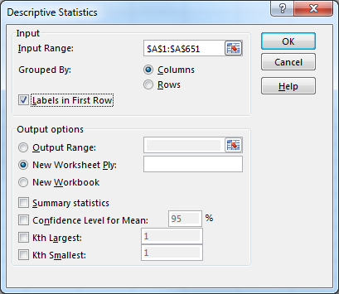

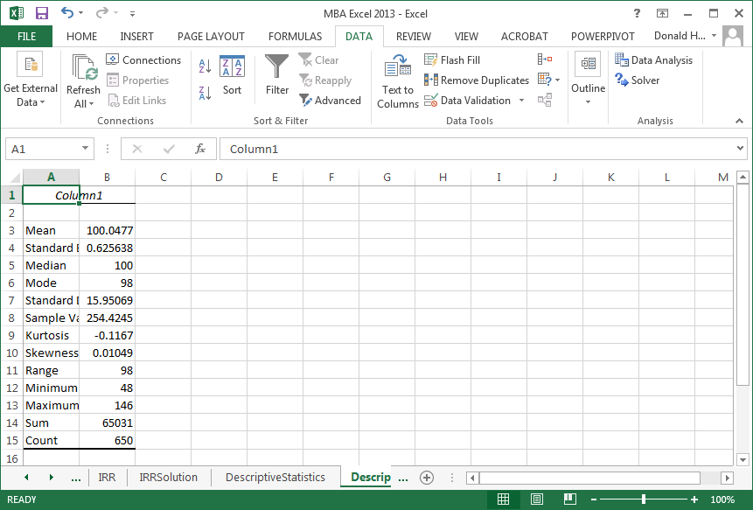

**Session 2.7: Correlations**

Correlation analysis identifies how two or more variables are related. For this exercise, use the Correlation spreadsheet. This spreadsheet records the upward or downward movement of stock by month.

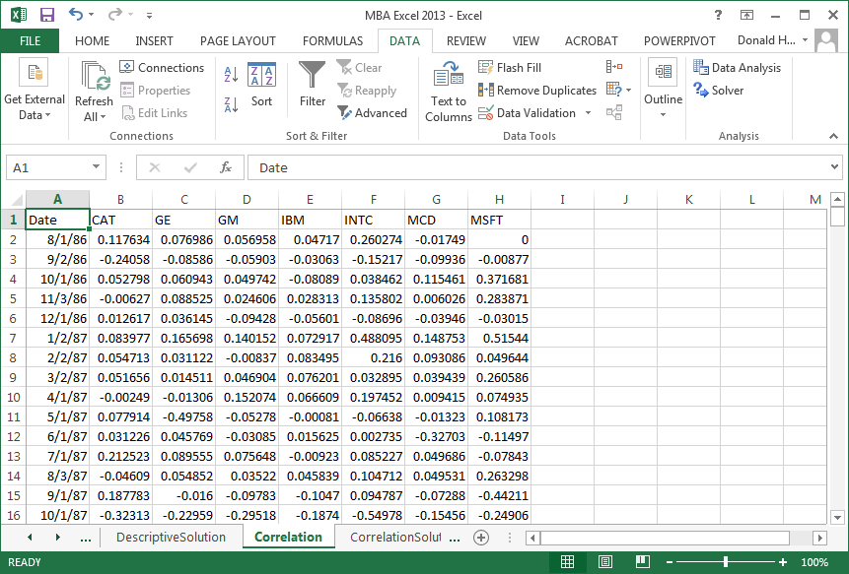

The stocks listed are Caterpillar, General Electric, General Motors, IBM, Intel, McDonalds and Microsoft. Click on the data tab, data analysis, correlation, then OK. Highlight columns B through H, group by columns, check Labels in First Row, then OK.

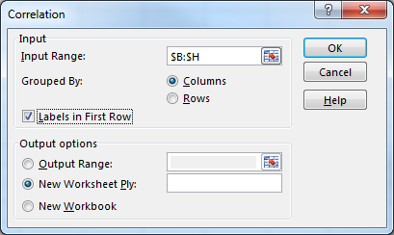

The result is shown below. A positive correlation means that when one variable increases, the other increases. A negative correlation means that when one increases, the other decreases.

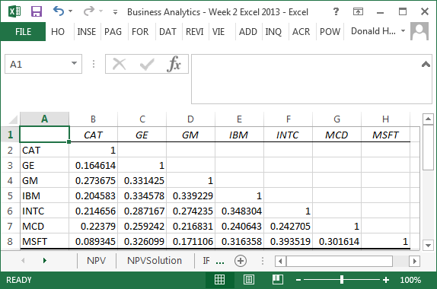

**Session 2.9: Univariate Linear Regression**

**Regression Assumptions**

Regression is a technique that attempts to measure the relationship between and outcome variable (dependent) and explanatory variables (independent). To use linear regression, there are three key assumptions

1. relationship between x and y is linear
2. the x’s are fixed numbers, not random variables (non-stochastic), not related to each other, i.e., independent: Corr(Xi,Xj)=0
3. the error terms:
   1. have zero mean and constant variance: E(εi) = 0, V(εi) = σ2
   2. the error terms are independent: Cov(εi,εj) = 0
   3. the error terms are normally distributed ~N(0,σ2)

Violation of these assumptions requires the use of more sophisticated techniques.

**Straight line relationships**

When you want to determine if there is a straight line relationship in statistics, you can run a regression. Excel has the ability to perform regression analysis. For example, if you wanted to model the relationship between items produced and factory costs, you could estimate the linear relationship. Units produced would be called the independent variable; production costs would be the dependent variable. The output, costs, depends on the input, number of units produced.

For this example, use the Regression spreadsheet.

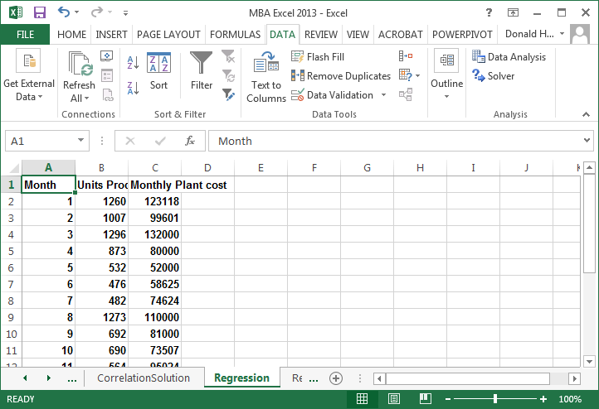

Let’s first draw a scatterplot to see what the data looks like.

1. Click on the Insert tab
2. Highlight the the cells b1:c15
3. Click on Scatter in the charts group.

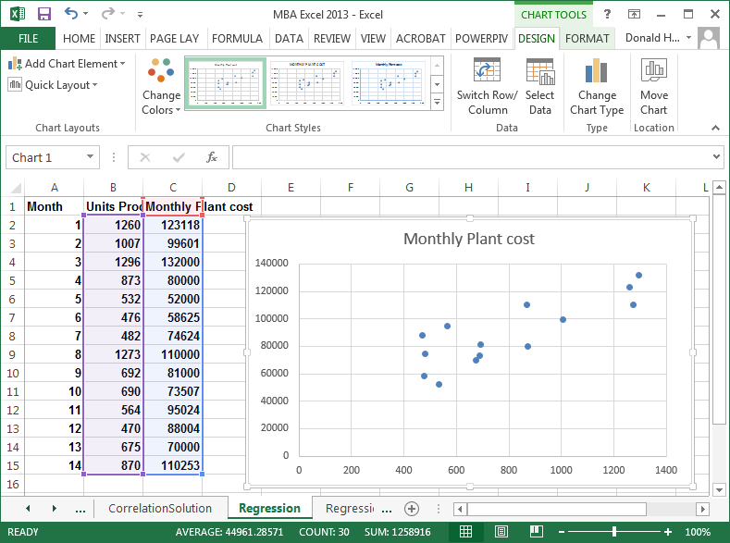

Reviewing the chart, it appears that there is a linear relationship. We will therefore perform a linear regression. Click on any data point, right click, then add trendline.

In the Format Trendline, Trendline Options, select Linear, then check the boxes for Display Equation and Display R-squared value.

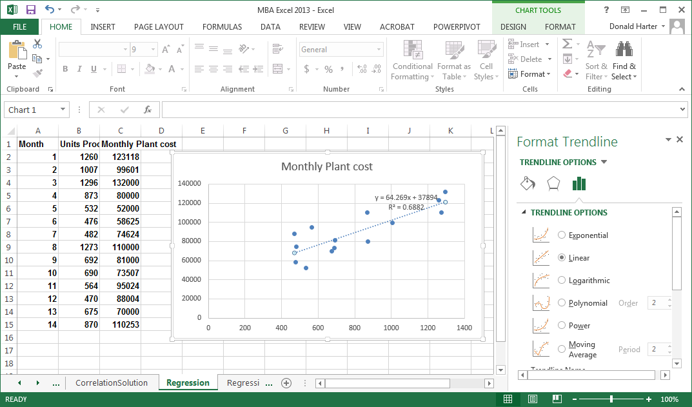

In the picture above, the coefficient on x is approximately 64. This means that as unit production increases by one, costs increase by $64. What does the number 37,894 represent? What does the R2 = 0.6882 mean?

**Session 2.10: Exponential regression**

Some data relationships are not linear, but grow at an increasing rate. These curves often follow the exponential growth curve. An exponential growth curve will have the same percentage growth per period compounded over time. Use the Exponential spreadsheet.

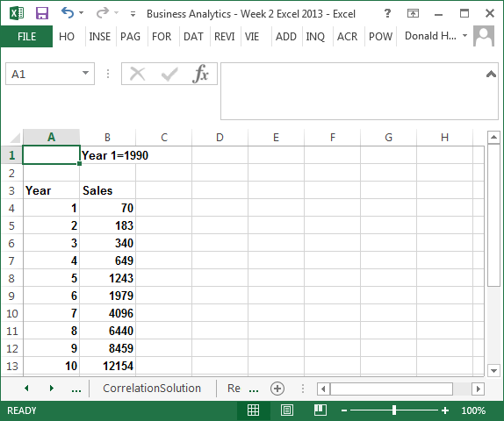

Let’s first draw a scatterplot to see what the data looks like.

1. Click on the Insert tab
2. Highlight the the cells a3:b13
3. Click on Scatter in the charts group.

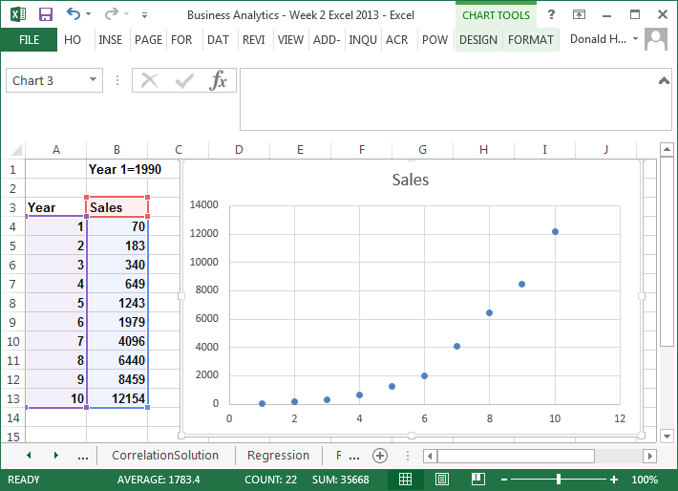

This data definitely does not look linear. So let’s use the exponential curve. Click on any data point, right click, then add trendline. Select exponential, display equation and display R-squared, then Close.

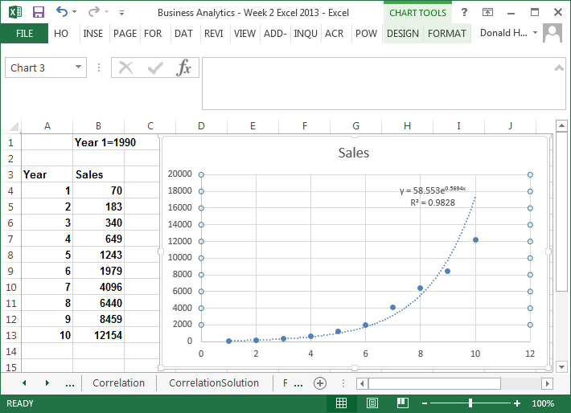

**Session 2.11: Power regression**

The power curve allows you to examine economies of scale and diseconomies of scale. Economies of scale means that you become more efficient as volume increases. Diseconomies of scale means that you become less efficient as volume increases. Use the Power spreadsheet.

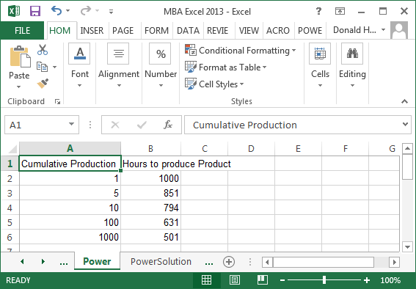

Let’s graph as before. Click on Insert, Scatter.

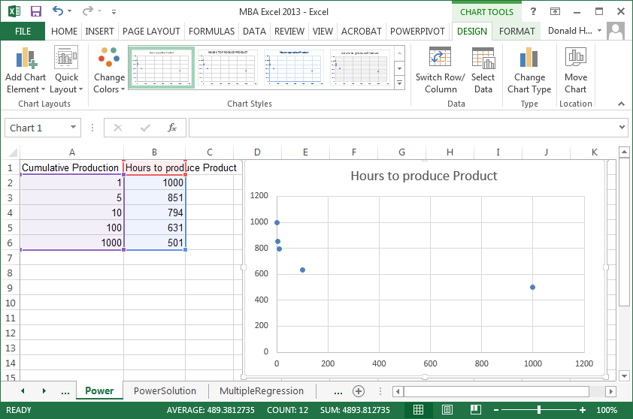

Now click on any data point in the graph, right click, add trendline. Click on Power, display equation, display R-squared.

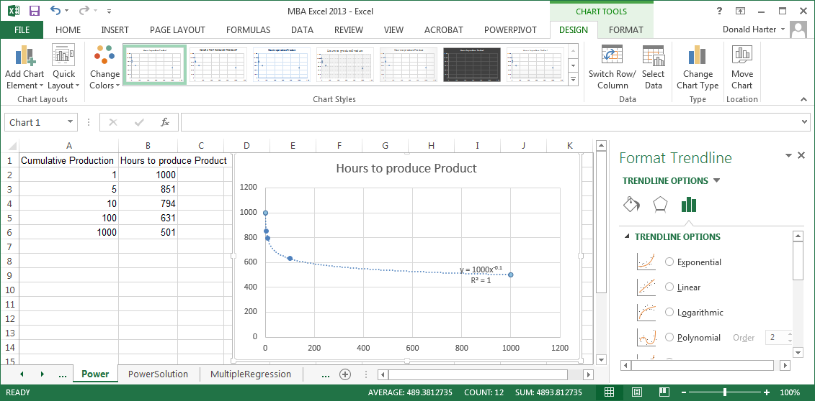

**Session 2.12: Multivariate regression**

When we reviewed linear regression earlier, we only had one independent variable. Multiple regression includes several independent variables. Use the Multiple Regression spreadsheet.

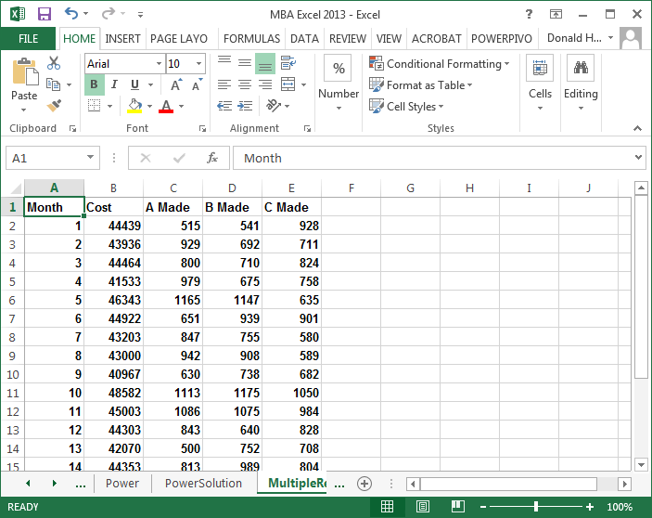

To run a multiple regression:

1. Click on the data tab, data analysis, regression, then OK.
2. For the Y-range, highlight the values in the B column for cost
3. For the X-range, highlight the values in the C, D, and E columns.
4. If you included the headings at the top of the columns, click labels.

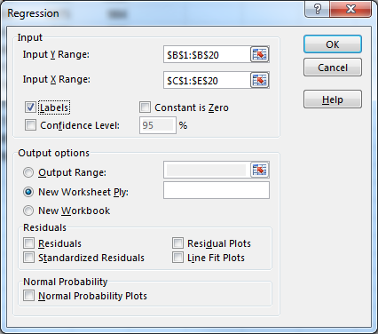

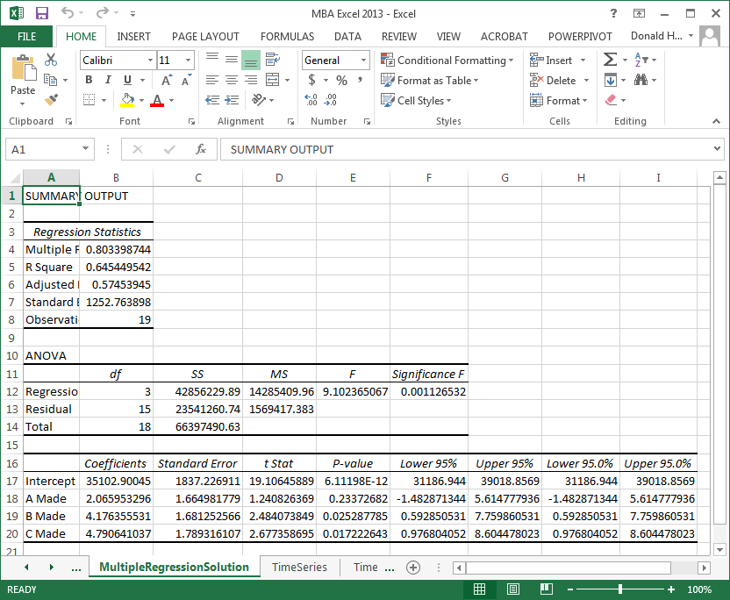

**Session 2.13: Time series moving average regression**

Time series problems have data where one data point is dependent on the previous data point. For example, the closing price of Microsoft stock can be tracked day by day. Today’s price is dependent on yesterday’s price. This dependency from one day to the next, or one time period to the next, is a characteristic of time series data.

Often there is so much variation in time series data that it’s hard to see trends. Seasonality also masks a trend. Seasonality is variations in data due to high or low points that occur at regular intervals. Create a scatter plot for the Amazon data using the Time Series spreadsheet. For this scatter plot, select the option to connect the dots.

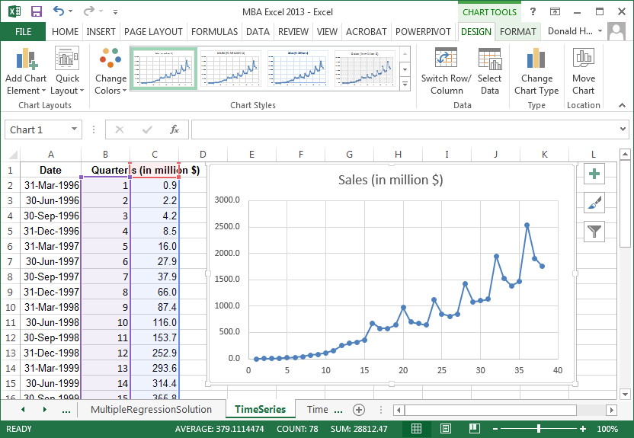

Notice that there is seasonality in the data. Amazon sales tend to peak during the fourth quarter of each year due to holiday sales. However, this seasonality masks the true trend. A moving average helps to see the trend.

To add a moving average line, follow these steps:

1. Right click on a data point.
2. Click on Add Trendline
3. Click the checkbox for moving average. Since we have quarterly data, let’s identify the number of periods as four.

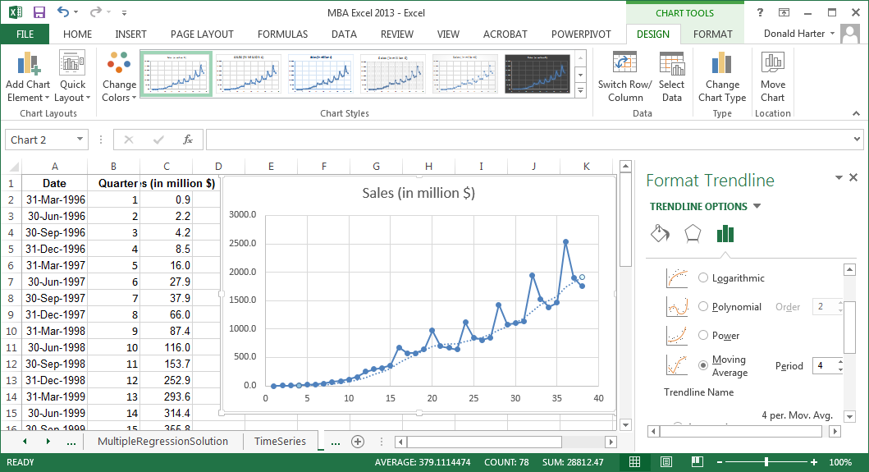

The moving average line is superimposed on the graph. It’s now very clear what the trend looks like when a moving average accounts for seasonality.